People who have dogs and no kids, allow their pets to govern their life decisions. We bought a house with property for the just for our spoiled dogs. When we moved to the house, fencing the yard was high on the arduous list of chores that came with our new house purchase. Our yard is over an acre, and I didn’t trust my dogs to have free reign over the yard while we were away at work. Our dogs have always lived in apartments or townhouses, so this was all new to them. I trusted that they wouldn’t run away but I was more concerned with the things they would roll in or eat while I was away. This led to the decided to convert the half the shed into a dog kennel and limit the amount of yard the dogs could use. The first step of my dog kennel project, putting up the fence.

Putting up the Fence

My dogs are middle age and not obnoxious, so I felt comfortable using steel U-fence post for the main portion of the fence and 4x4 post for the corner anchors. This also saved me lots of time and backache since I could just hammer in the U-fence post. For the fence I used ____ high welded fence. I chose that height because my big dog can jump pretty high and had not earned my trust yet with his newfound yard freedoms.

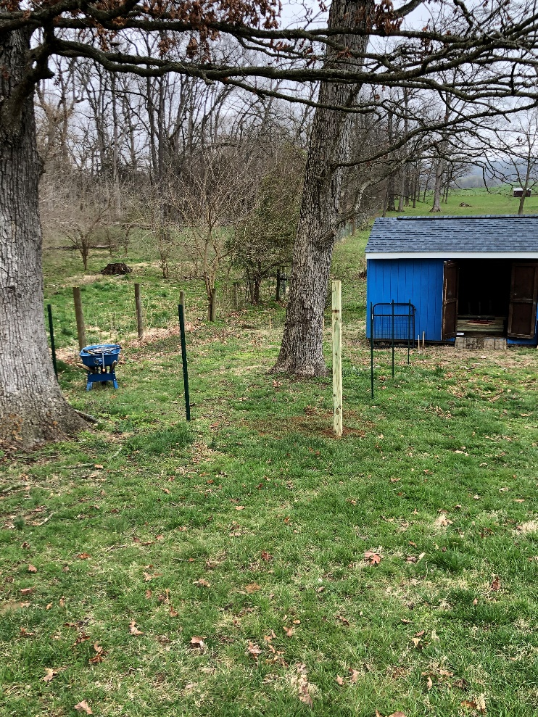

To ensure that the dogs did not dig under the fence, I dug up the ground around the fence and laid fence on the ground to bury. For this I rolled the fence on the ground and just cut it in half the length of the section that I was installing. I twisted the fence on the ground with the fence that was already standing.

